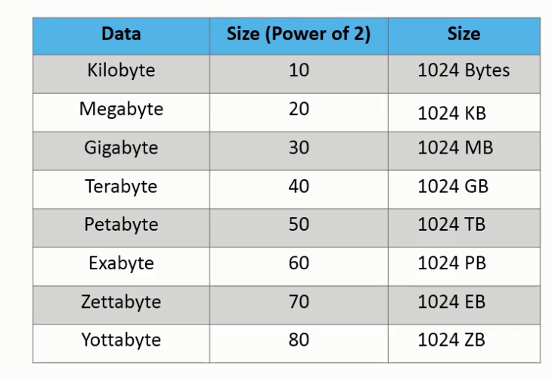

MapReduce

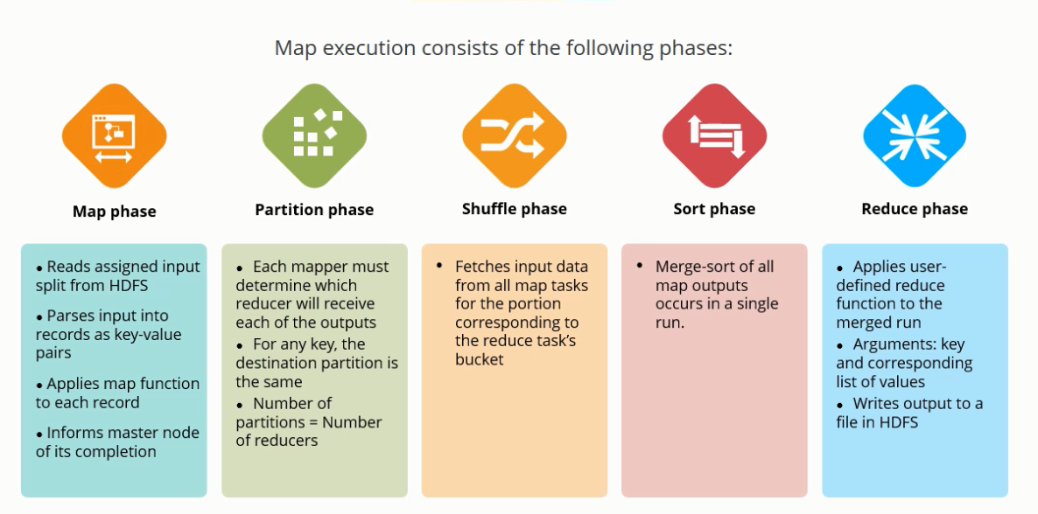

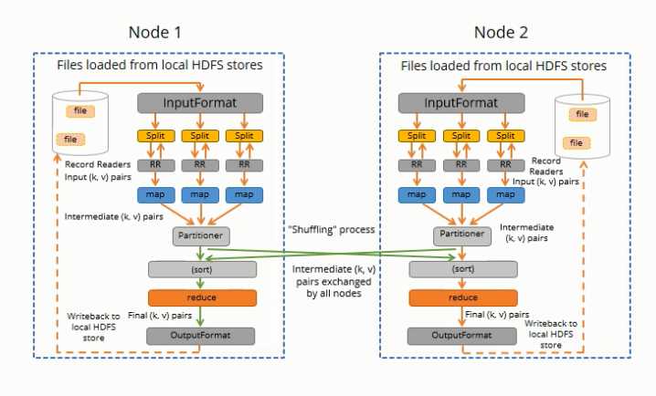

File formats

Text file

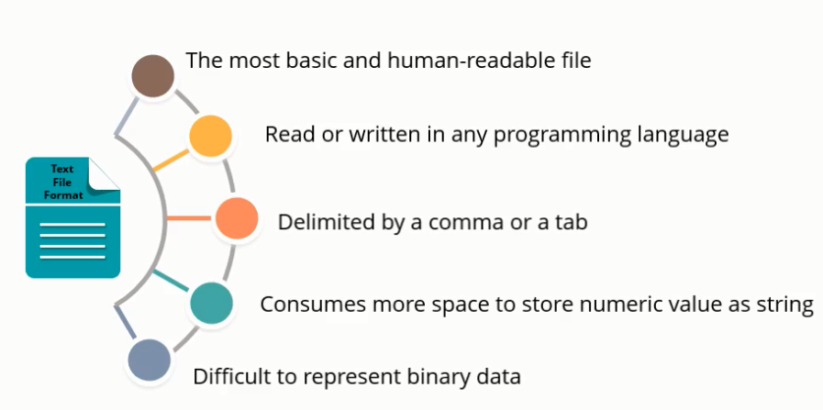

Sequence File

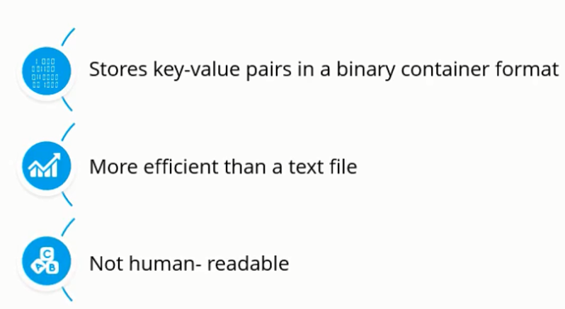

Avro File

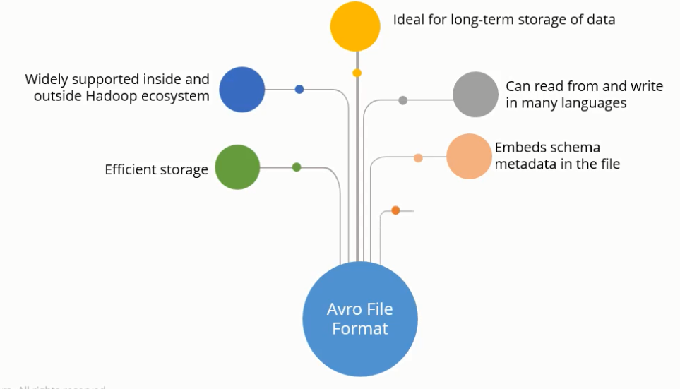

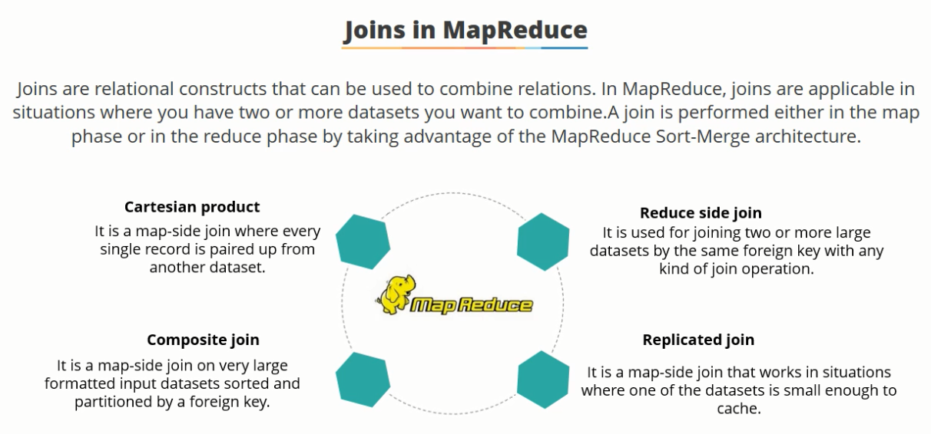

**Joins in MapReduce**

Just like SQL join, we can also perform join operations in MapReduce on different data sets. There are two types of join operations in MapReduce:

* **Map Side Join/Replicated Join (one of the table is small enough to cache- Broadcast join):** As the name implies, the join operation is performed in the map phase itself. Therefore, in the map side join, the mapper performs the join and it is mandatory that the input to each map is partitioned and sorted according to the keys.
* **Reduce Side Join:**As the name suggests, in the reduce side join, the reducer is responsible for performing the join operation. It is comparatively simple and easier to implement than the map side join as the sorting and shuffling phase sends the values having identical keys to the same reducer and therefore, by default, the data is organized for us.

Whenever, we apply join operation, the job will be assigned to a Map Reduce task which consists of two stages- a ***‘Map stage***’ and a ‘***Reduce stage***’. A mapper’s job during Map Stage is to “read” the data from join tables and to “return” the **‘join key’** and **‘join value’** pair into an intermediate file. Further, in the shuffle stage, this intermediate file is then sorted and merged. The reducer’s job during reduce stage is to take this sorted result as input and complete the task of join.

[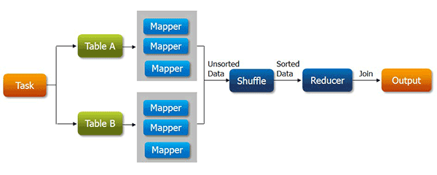](https://cdn.edureka.co/blog/wp-content/uploads/2013/11/joins1.png)

#### **How will the map-side join optimize the task?**

Assume that we have two tables of which one of them is a small table. When we submit a map reduce task, a Map Reduce local task will be created before the original join Map Reduce task which will read data of the small table from HDFS and store it into an in-memory hash table. After reading, it serializes the in-memory hash table into a hash table file.

**In the next stage,** when the original join Map Reduce task is running, it moves the data in the hash table file to the Hadoop distributed cache, which populates these files to each mapper’s local disk. So all the mappers can load this persistent hash table file back into the memory and do the join work as before. The execution flow of the optimized map join is shown in the figure below. After optimization, the small table needs to be read just once. Also if multiple mappers are running on the same machine, the distributed cache only needs to push one copy of the hash table file to this machine.

## Advantages of using map side join:

* Map-side join helps in minimizing the cost that is incurred for sorting and merging in the shuffle and reduce stages.
* Map-side join also helps in improving the performance of the task by decreasing the time to finish the task.

[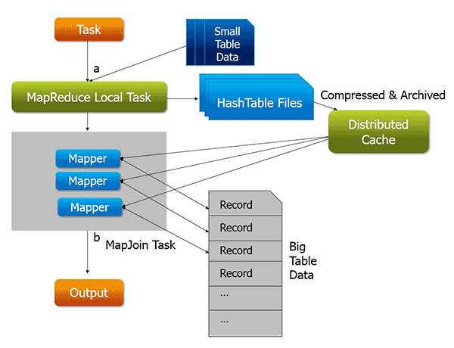](https://cdn.edureka.co/blog/wp-content/uploads/2013/11/joins2.png)

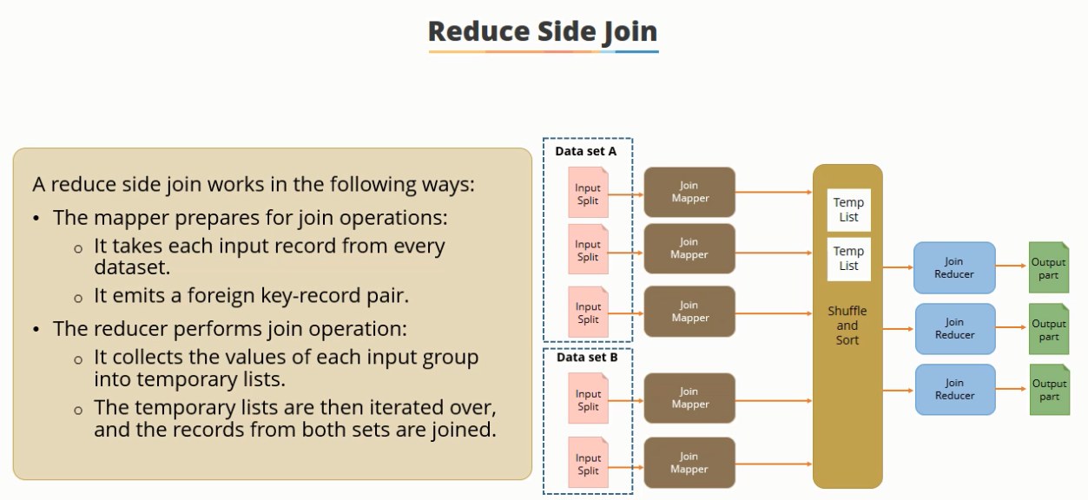

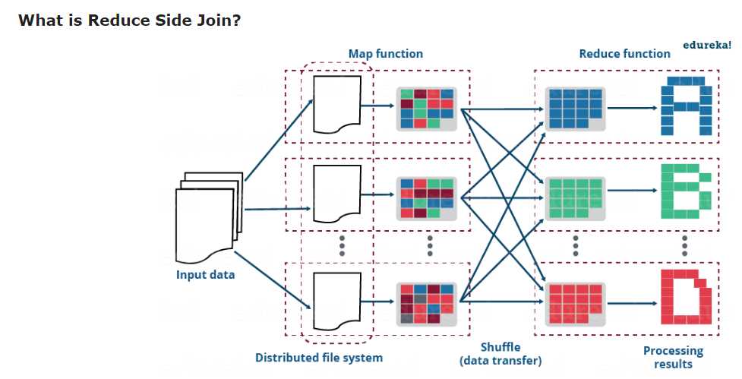

The reduce side join is a process where the join operation is performed in the reducer phase. Basically, the reduce side join takes place in the following manner:

* Mapper reads the input data which are to be combined based on common column or join key.
* The mapper processes the input and adds a tag to the input to distinguish the input belonging from different sources or data sets or databases.
* The mapper outputs the intermediate key-value pair where the key is the join key.
* After the sorting and shuffling phase, a key and the list of values is generated for the reducer.
* Now, the reducer joins the values present in the list with the key to give the final aggregated output.

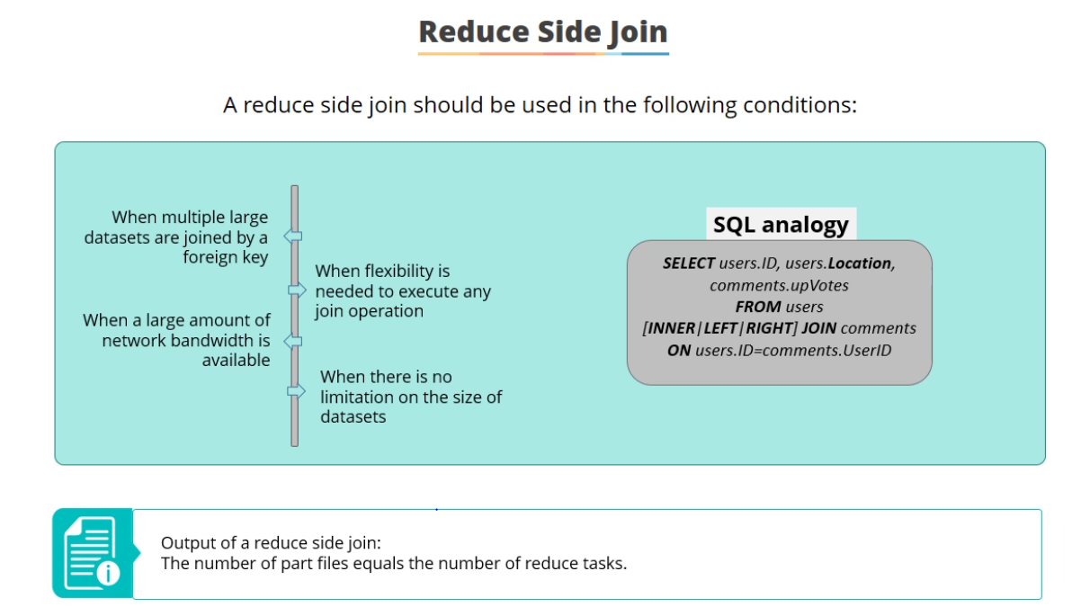

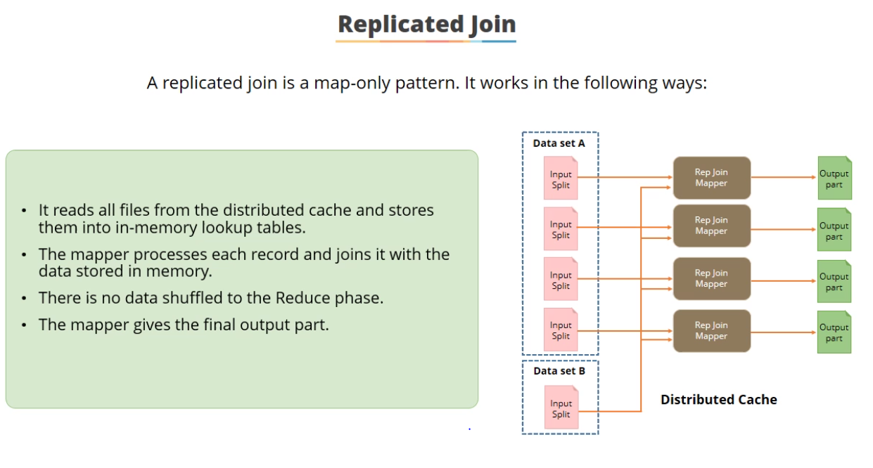

Distributed Cache on Smaller Table- One relation has to fit in memory. The smaller table is replicated in each node and loaded in memory. The join happens at map side without reducer involvement which significantly speeds up the process since this avoids shuffling all data across the network. Filter to reduce table size with where clause.

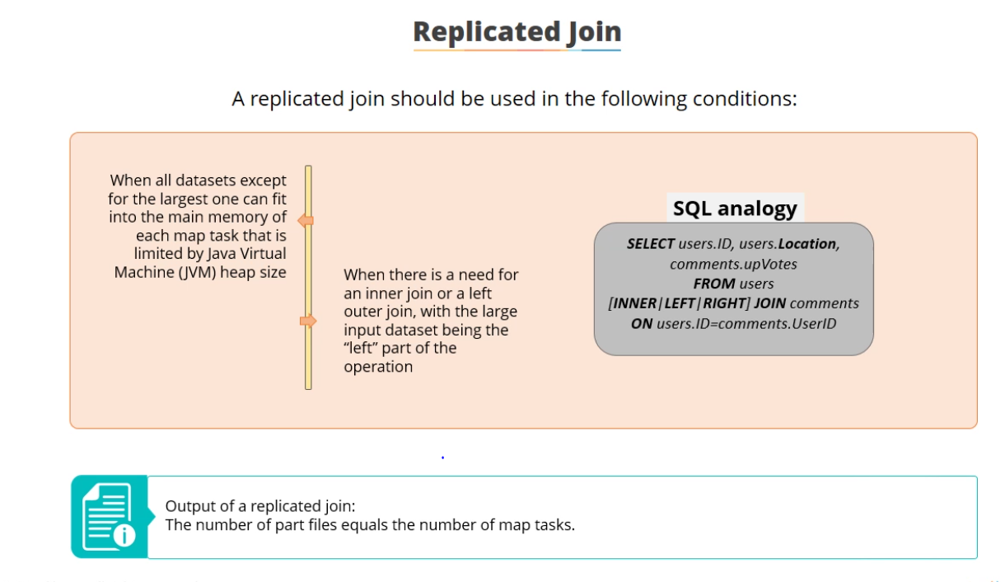

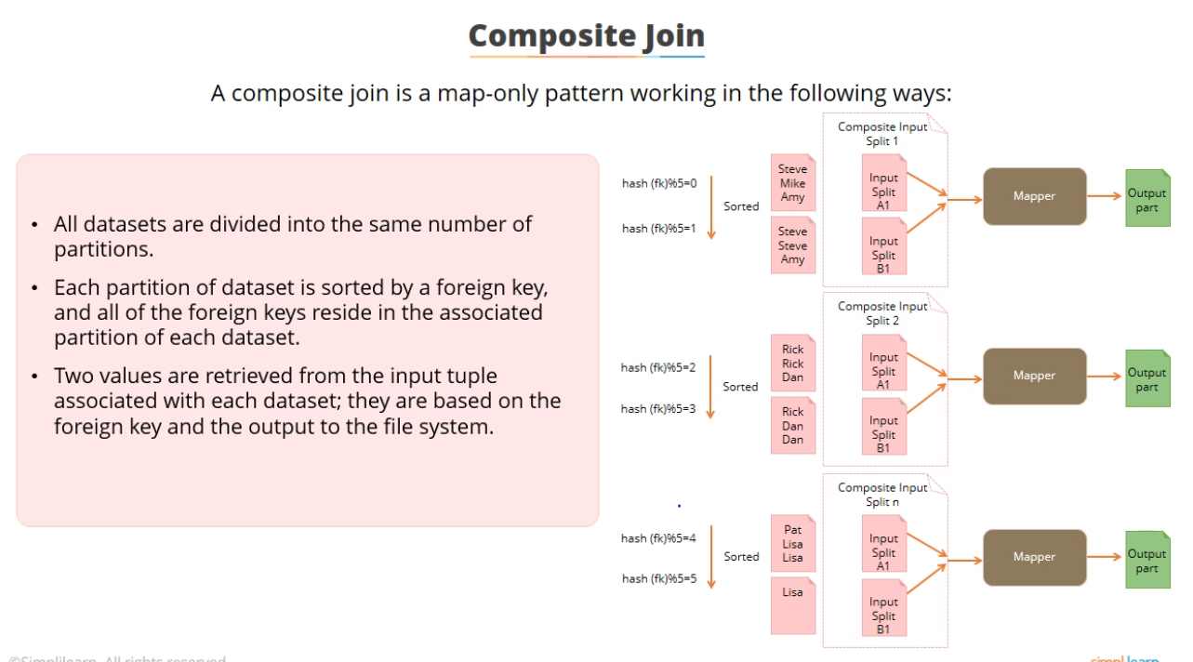

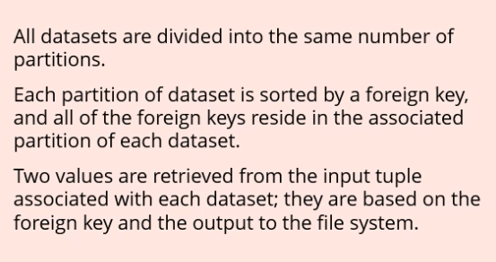

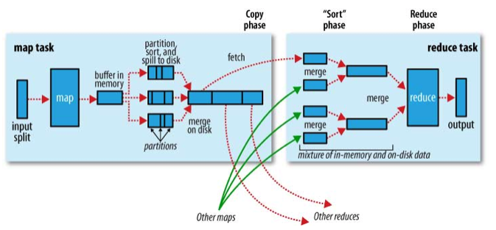

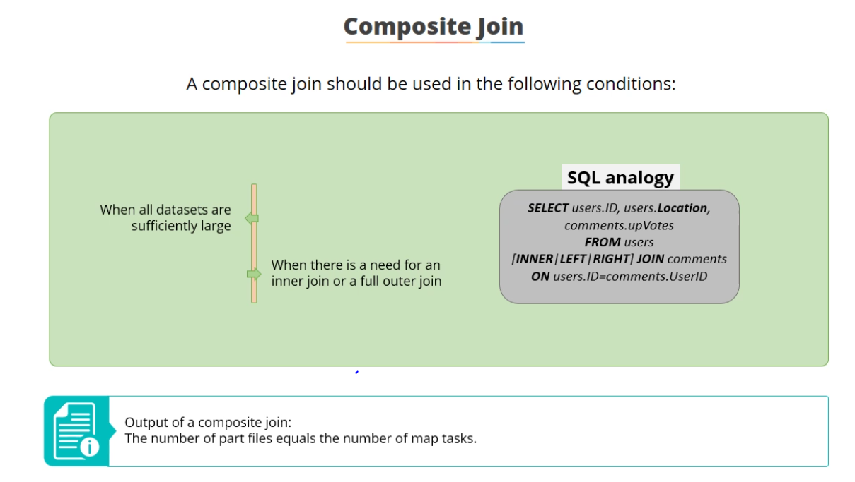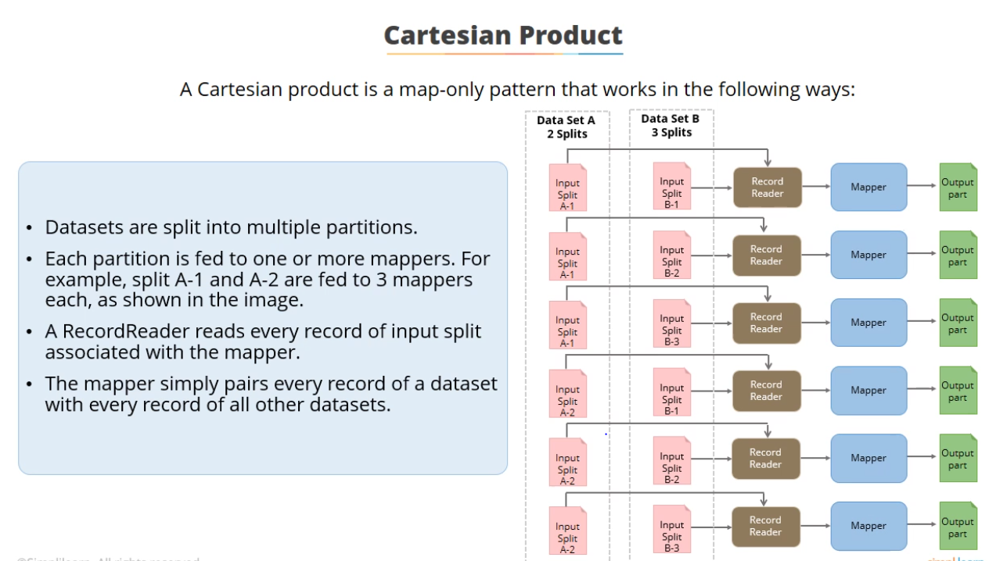

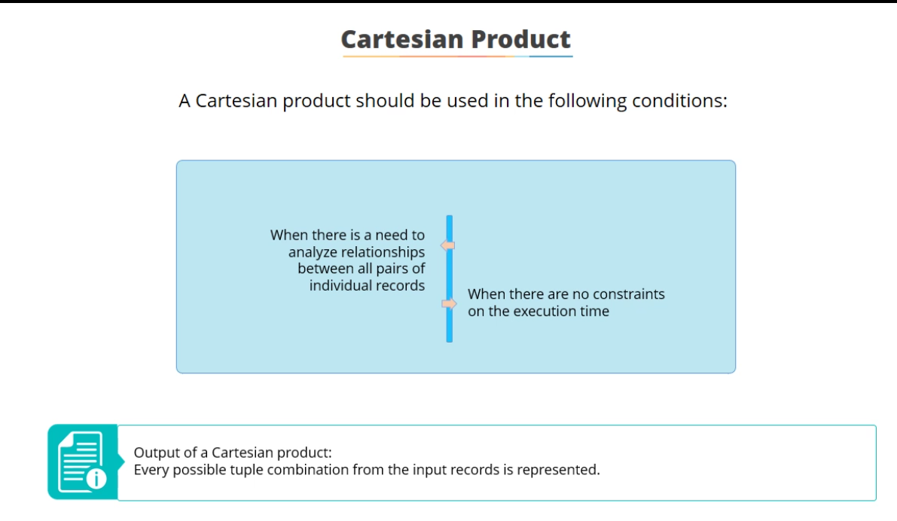

UDF with Hive (SELECT TRANSFORM)

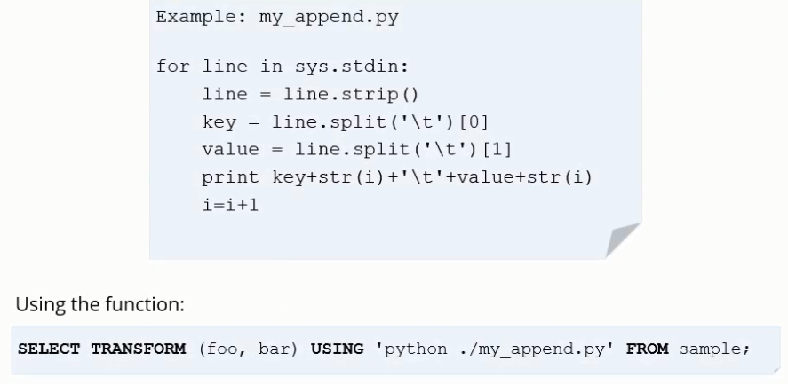

Hive and Impala

Metastore is used by both Hive and Impala (stored in Derby Database)



By default, the cached metadata for all tables is flushed. If you specify a table name, only the metadata for that one table is flushed. Even for a single table, INVALIDATE METADATA is more expensive than REFRESH, so prefer REFRESH in the common case where you add new data files for an existing table.



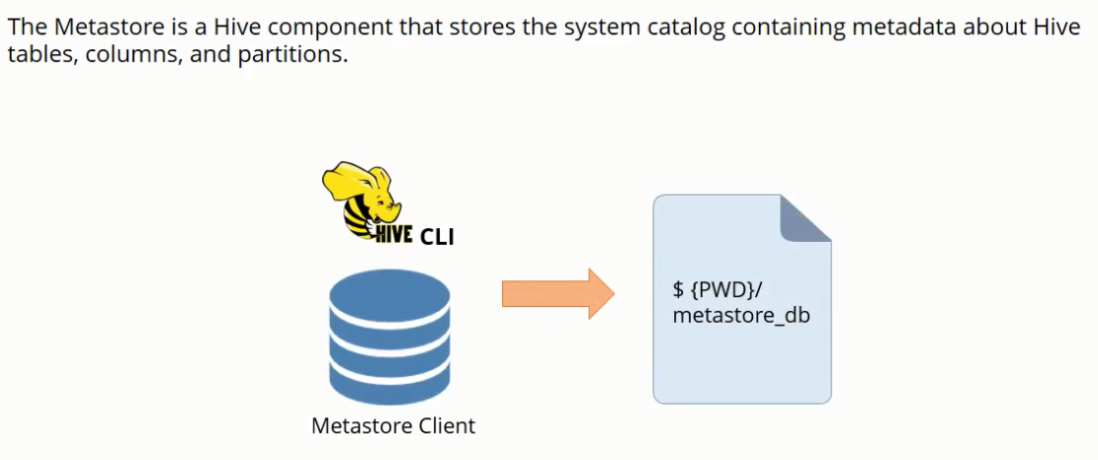

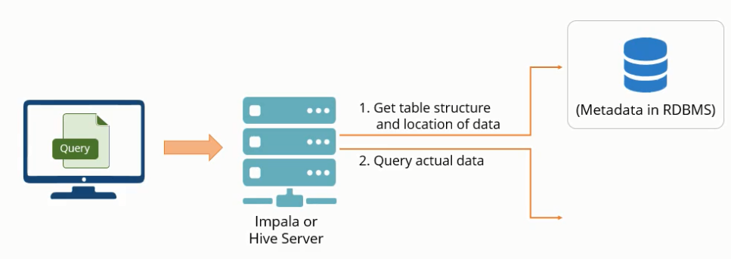

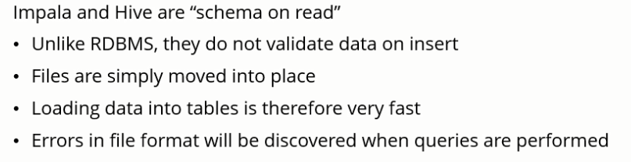

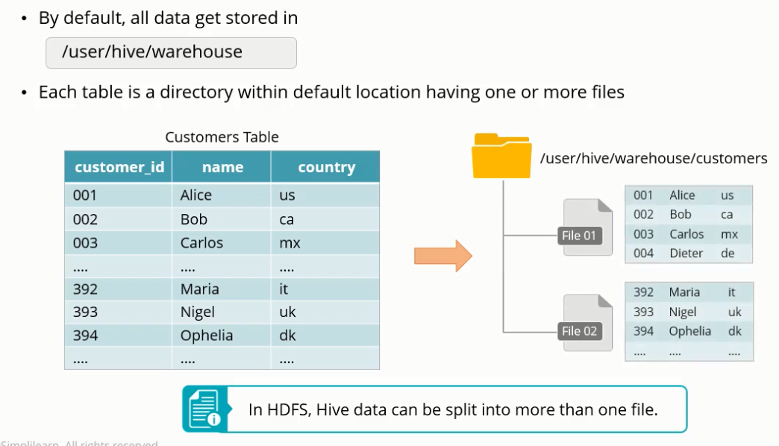

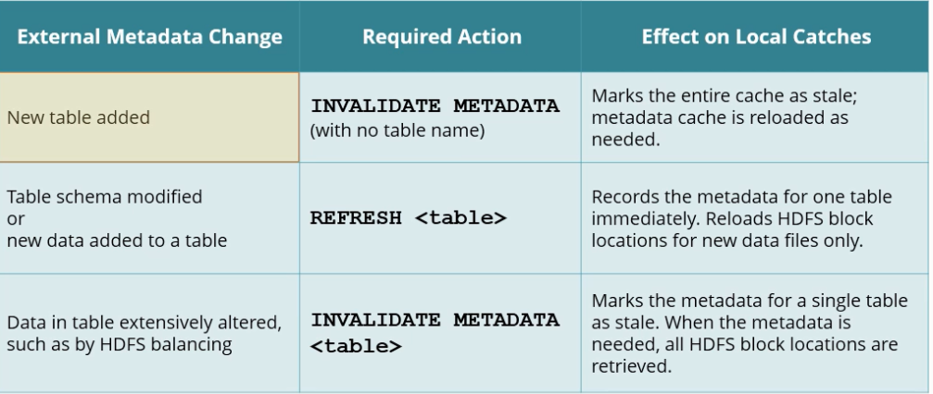

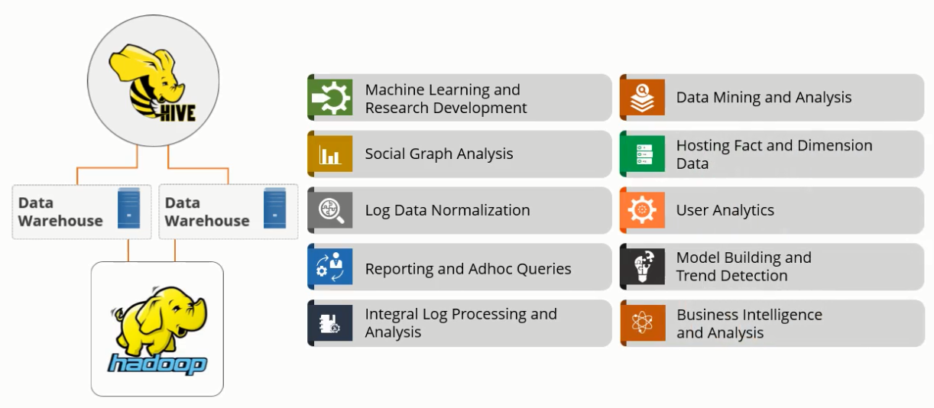

Components of Hive

1. Driver: Session handling, and connectivity with Hadoop and other components
2. Compiler
3. Shell
4. Metastore
5. Execution Engine

Compiler: 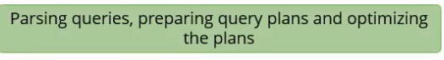

Execution Engine: 

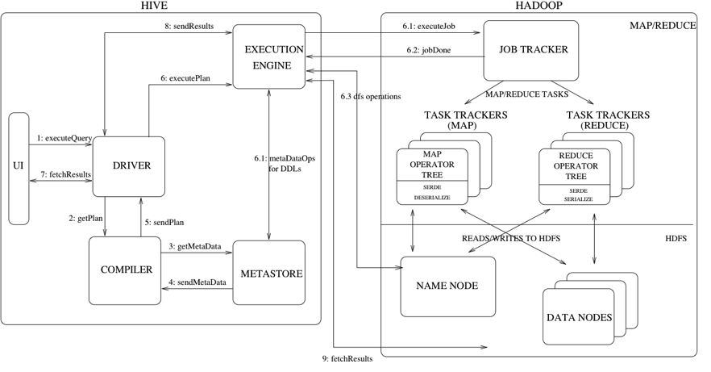

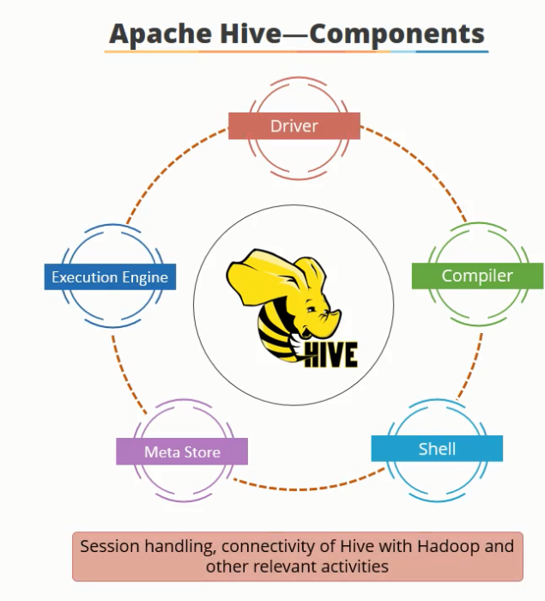

**Metastore**: 

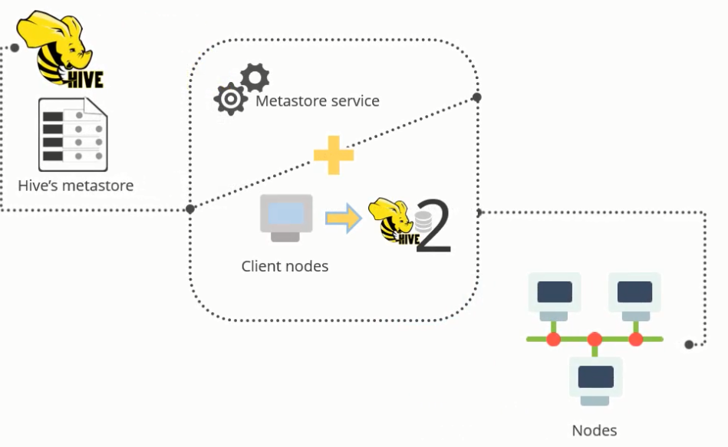

Hive Commands

Loading data from csv files

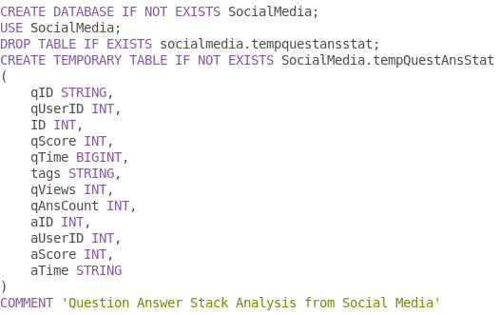

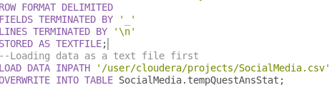

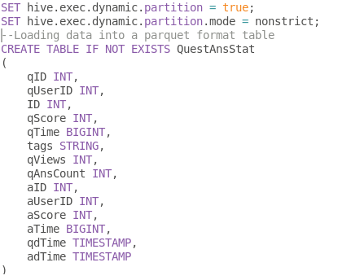

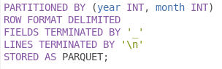

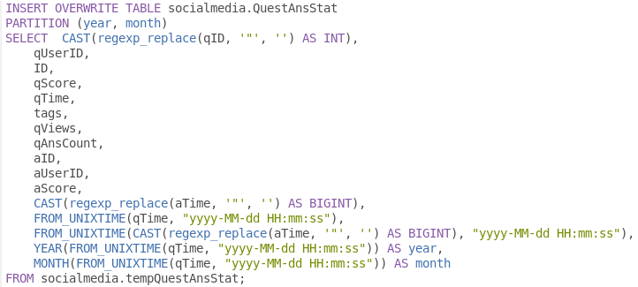

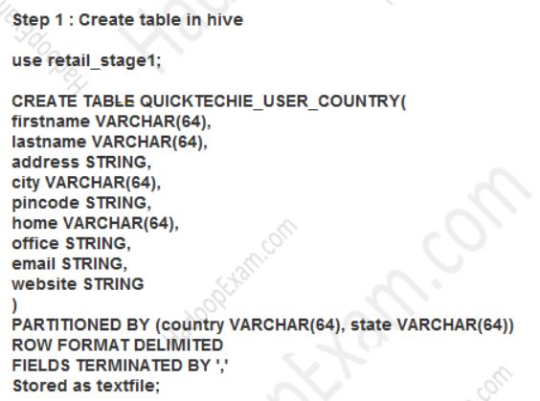



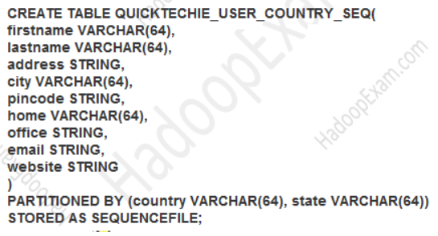

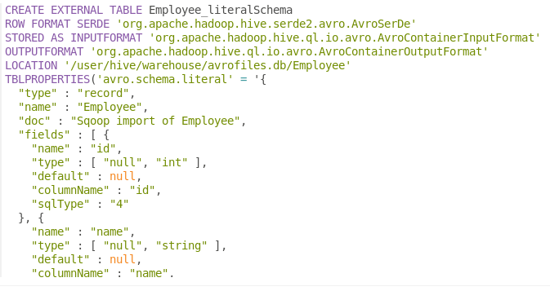

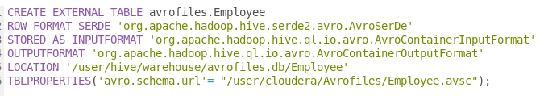

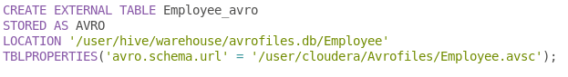

CREATE [EXTERNAL] TABLE foo(rowkey STRING, a STRING, b STRING)

STORED BY ‘org.apache.hadoop.hive.hbase.HBaseStorageHandler’

TBLPROPERTIES (‘hbase.table.name’ = ‘bar’);

CREATE TABLE foo(rowkey STRING, a STRING, b STRING)

STORED AS

INPUTFORMAT ‘org.apache.hadoop.hive.hbase.HiveHBaseTableInputFormat’

OUTPUTFORMAT ‘org.apache.hadoop.hive.hbase.HiveHBaseTableOutputFormat’

TBLPROPERTIES (‘hbase.table.name’ = ‘bar’);

CREATE TABLE foo(rowkey STRING, a STRING, b STRING)  
STORED BY ‘org.apache.hadoop.hive.hbase.HBaseStorageHandler’  
WITH SERDEPROPERTIES (‘hbase.columns.mapping’ = ‘:key,f:c1,f:c2’)  
TBLPROPERTIES (‘hbase.table.name’ = ‘bar’);

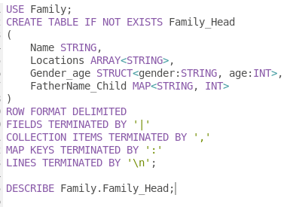

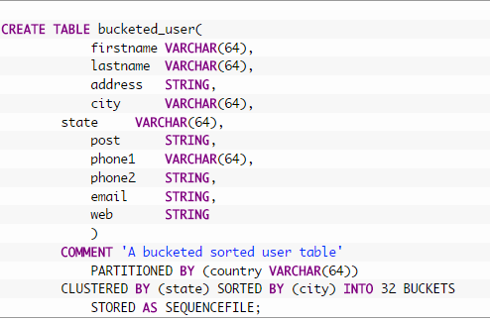

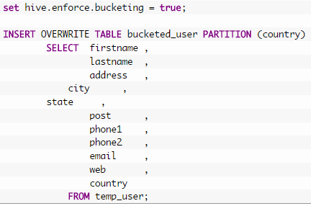

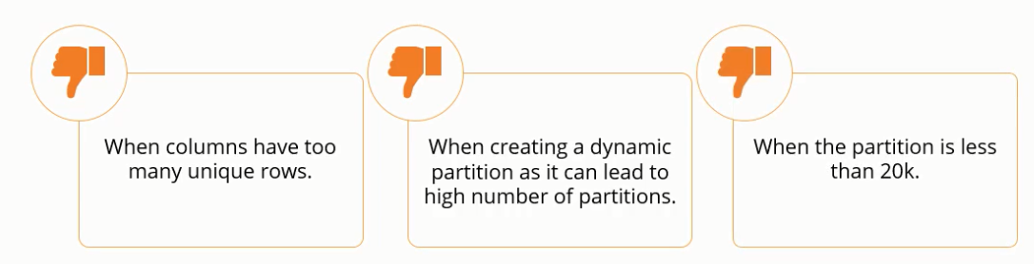

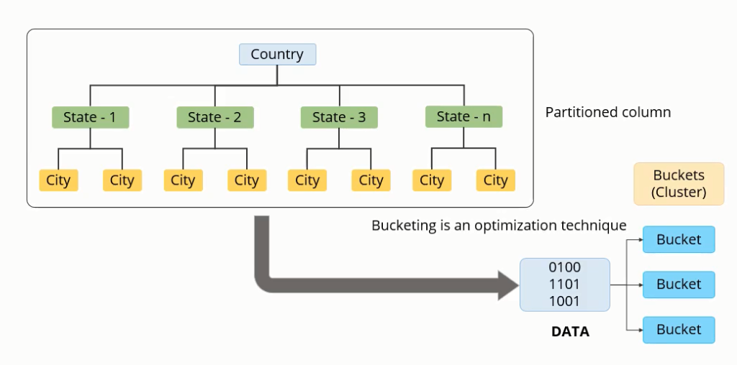

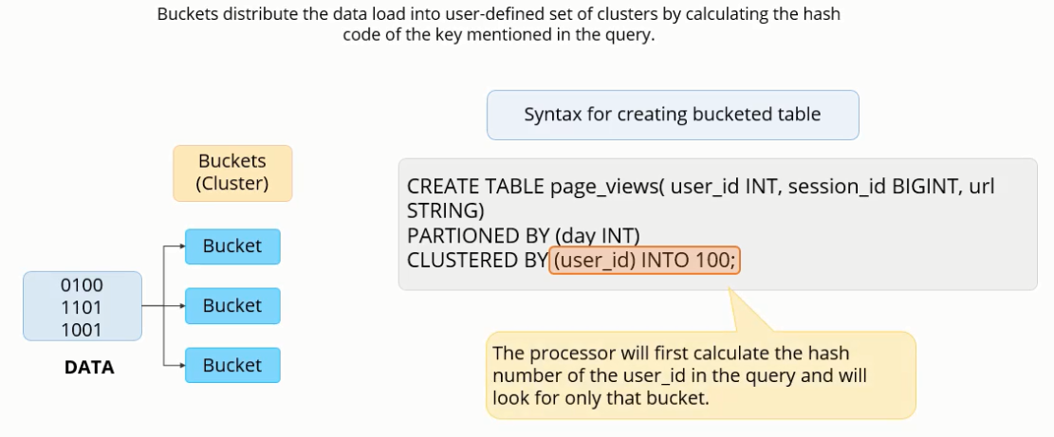

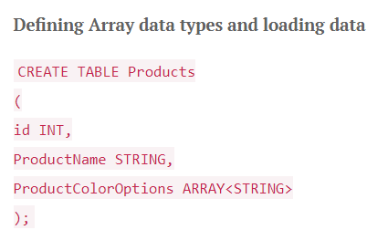

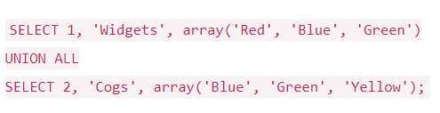

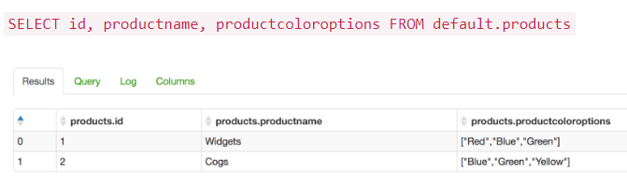

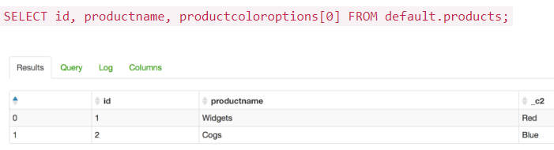

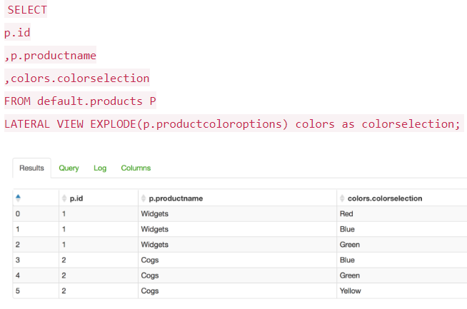



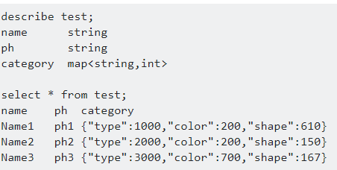

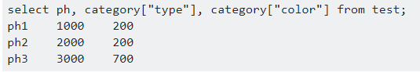

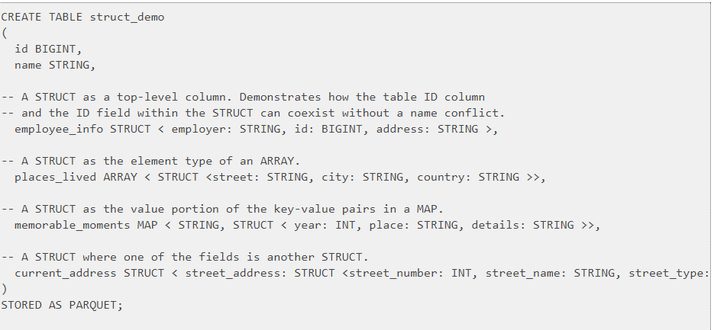

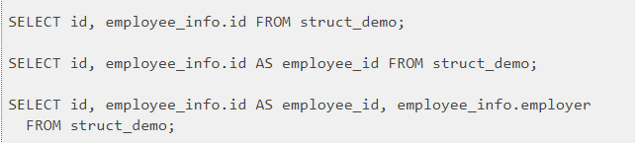

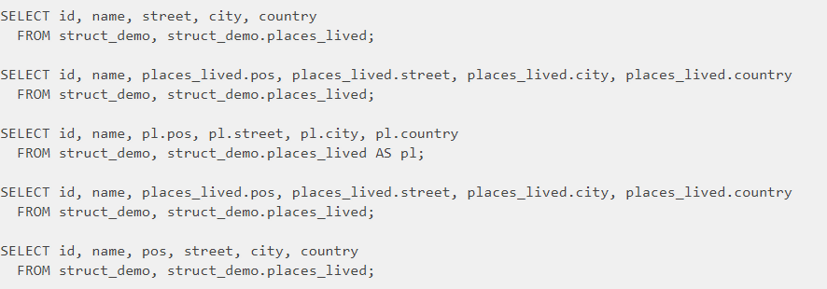

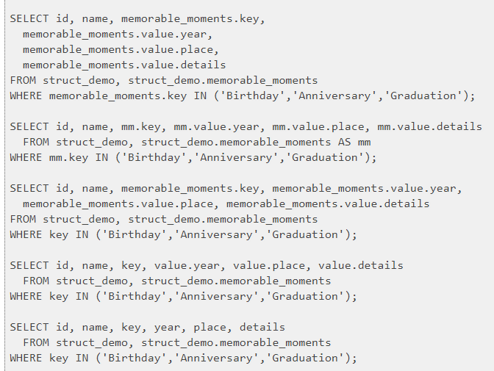

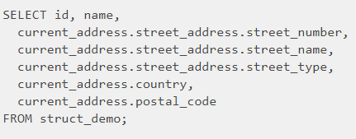

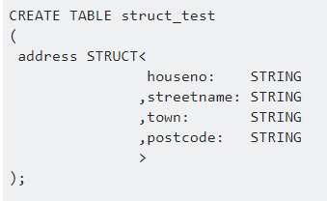



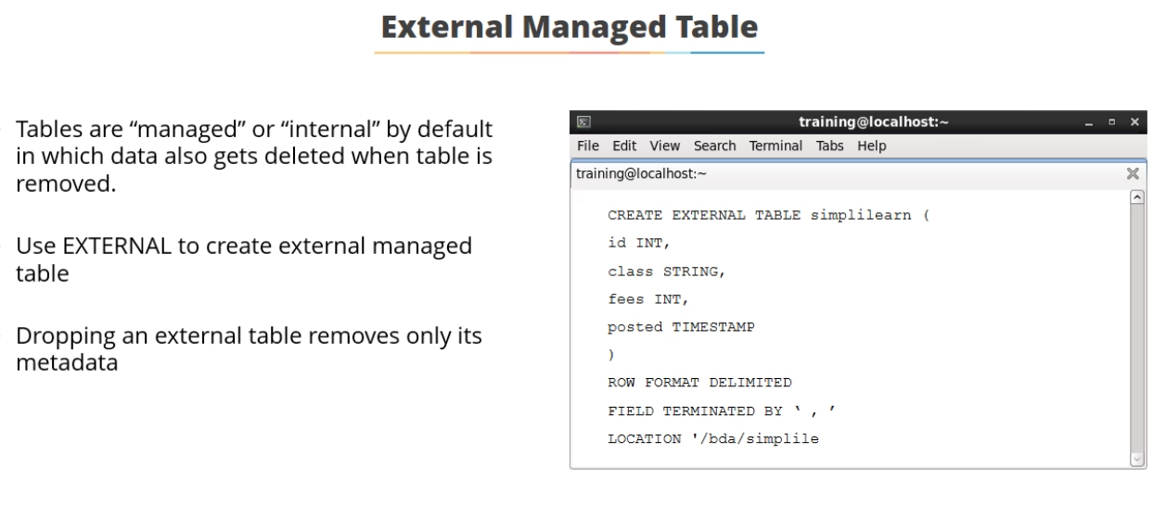

1. Partitioning Tables:

Hive partitioning is an effective method to improve the query performance on larger tables. Partitioning allows you to store data in separate sub-directories under table location. It greatly helps the queries which are queried upon the partition key(s). Although the selection of partition key is always a sensitive decision, it should always be a low cardinal attribute, e.g. if your data is associated with time dimension, then date could be a good partition key. Similarly, if data has association with location, like a country or state, then it’s a good idea to have hierarchical partitions like country/state.

set hive.exec.dynamic.partition=true; (mode non strict)

2. De-normalizing data:

Normalization is a standard process used to model your data tables with certain rules to deal with redundancy of data and anomalies. In simpler words, if you normalize your data sets, you end up creating multiple relational tables which can be joined at the run time to produce the results. Joins are expensive and difficult operations to perform and are one of the common reasons for performance issues. Because of that, it’s a good idea to avoid highly normalized table structures because they require join queries to derive the desired metrics.

3. Compress map/reduce output:

Compression techniques significantly reduce the intermediate data volume, which internally reduces the amount of data transfers between mappers and reducers. All this generally occurs over the network. Compression can be applied on the mapper and reducer output individually. Keep in mind that gzip compressed files cannot be spilt. That means this should be applied with caution. A compressed file size should not be larger than a few hundred megabytes, otherwise it can potentially lead to an imbalanced job. Other options of compression codec could be snappy, lzo, bzip, etc.

For map output compression set mapred.compress.map.output to true

For job output compression set mapred.output.compress to true

4. Map join:

Map joins are really efficient if a table on the other side of a join is small enough to fit in the memory. Hive supports a parameter, hive.auto.convert.join, which when it’s set to “true” suggests that Hive try to map join automatically. When using this parameter, be sure the auto convert is enabled in the Hive environment.

5. Bucketing:

Bucketing improves the join performance if the bucket key and join keys are common. Bucketing in Hive distributes the data in different buckets based on the hash results on the bucket key. It also reduces the I/O scans during the join process if the process is happening on the same keys (columns).

Additionally it’s important to ensure the bucketing flag is set (SET hive.enforce.bucketing=true;) every time before writing data to the bucketed table. To leverage the bucketing in the join operation we should SET hive.optimize.bucketmapjoin=true. This setting hints to Hive to do bucket level join during the map stage join. It also reduces the scan cycles to find a particular key because bucketing ensures that the key is present in a certain bucket.

6. Input Format Selection:

Input formats play a critical role in Hive performance. For example, JSON, the text type of input formats, is not a good choice for a large production system where data volume is really high. These types of readable formats actually take a lot of space and have some overhead of parsing (e.g. JSON parsing). To address these problems, Hive comes with columnar input formats like RCFile, ORC etc. Columnar formats allow you to reduce the read operations in analytics queries by allowing each column to be accessed individually. There are some other binary formats like Avro, sequence files, Thrift and Proto, but can be helpful in various use cases too.

7. Parallel execution:

Hadoop can execute MapReduce jobs in parallel, and several queries executed on Hive automatically use this parallelism. However, single, complex Hive queries commonly are translated to a number of MapReduce jobs that are executed by default sequencing. Often though, some of a query’s MapReduce stages are not interdependent and could be executed in parallel. They then can take advantage of spare capacity on a cluster and improve cluster utilization while at the same time reducing the overall query executions time. The configuration in Hive to change this behavior is merely switching a single flag SET hive.exec.parallel=true.

8. Vectorization:

Vectorization allows Hive to process a batch of rows together instead of processing one row at a time. Each batch consists of a column vector which is usually an array of primitive types. Operations are performed on the entire column vector, which improves the instruction pipelines and cache usage. To enable vectorization, set this configuration parameter SET hive.vectorized.execution.enabled=true.

9. Skewed Joins

hive.optimize.skewjoin property = true

SORT BY

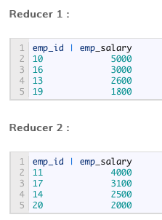

DISTRIBUTE BY

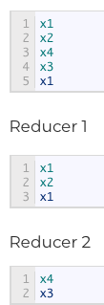

CLUSTER BY (sort and distribute)

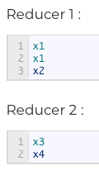

**IMPALA**

**Optimization and performance Tuning**

* Choose the appropriate file format for the data: Parquet file format performs best because of its combination of columnar storage layout, large I/O request size, and compression and encoding
* Avoid data ingestion processes that produce many small files: When producing data files outside of Impala, prefer either text format or Avro, where you can build up the files row by row. Once the data is in Impala, you can convert it to the more efficient Parquet format
* Choose partitioning granularity based on actual data volume
* Use smallest appropriate integer types for partition key columns
* Gather statistics for all tables used in performance-critical or high-volume join queries
* Minimize the overhead of transmitting results back to the client: Aggregation (MIN, MAX, GROUP), filter, Limit

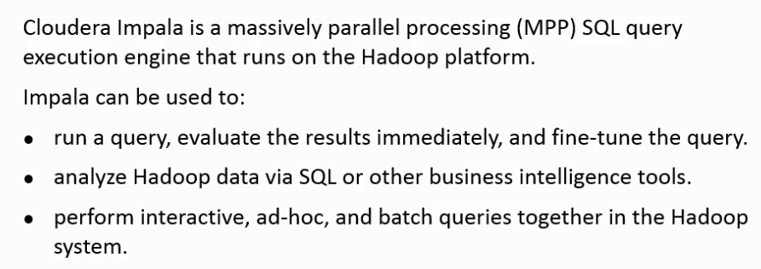

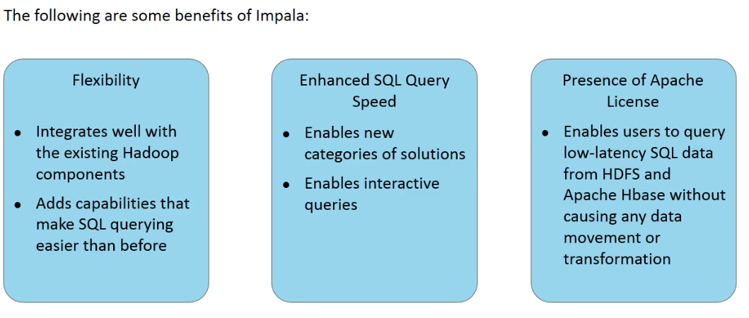

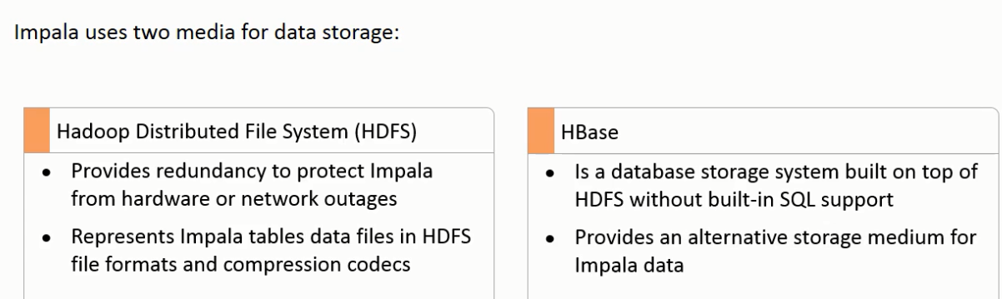

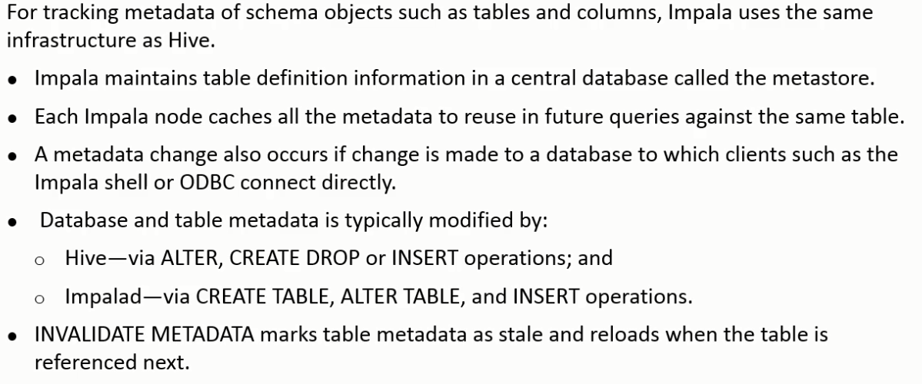

Impala supports uncorrelated subquery- Correlated queries have an outer dependency and uncorrelated query does not

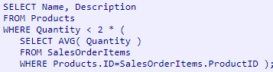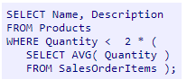

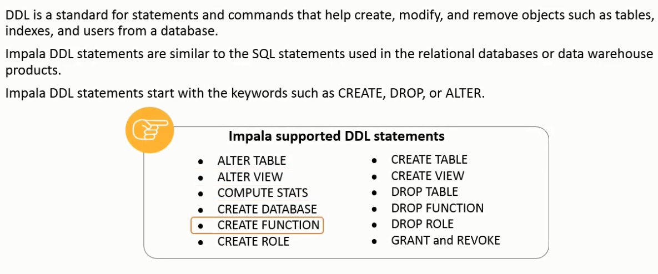

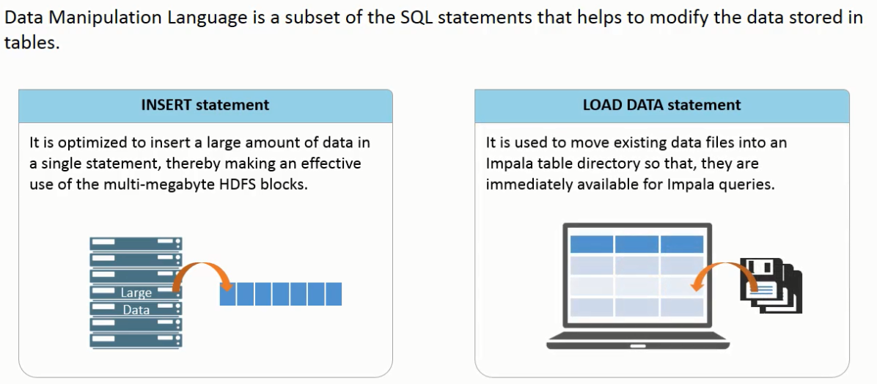

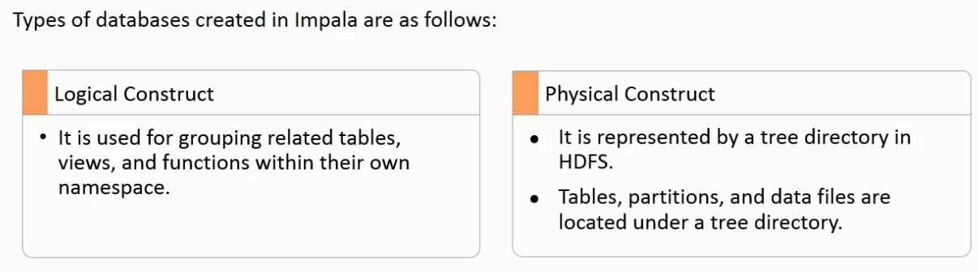

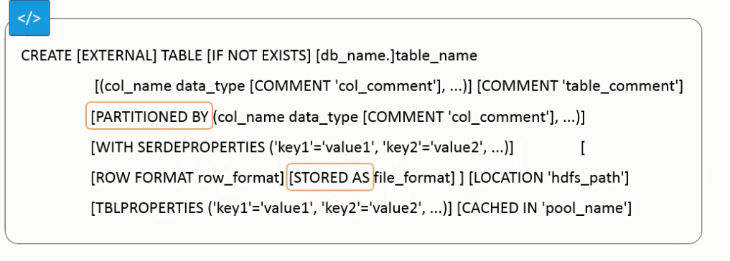

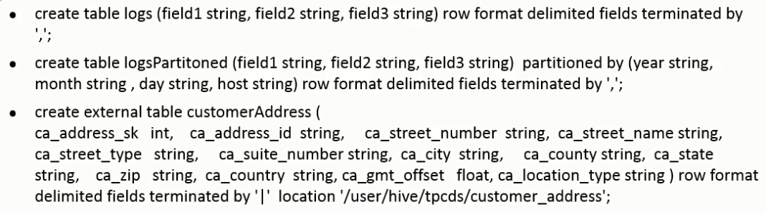

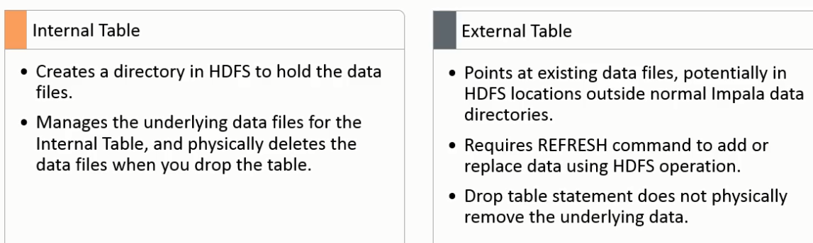

Load data



Load data into a partitioned table



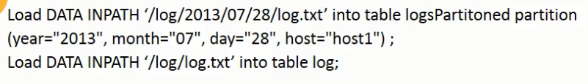

Alter table statements

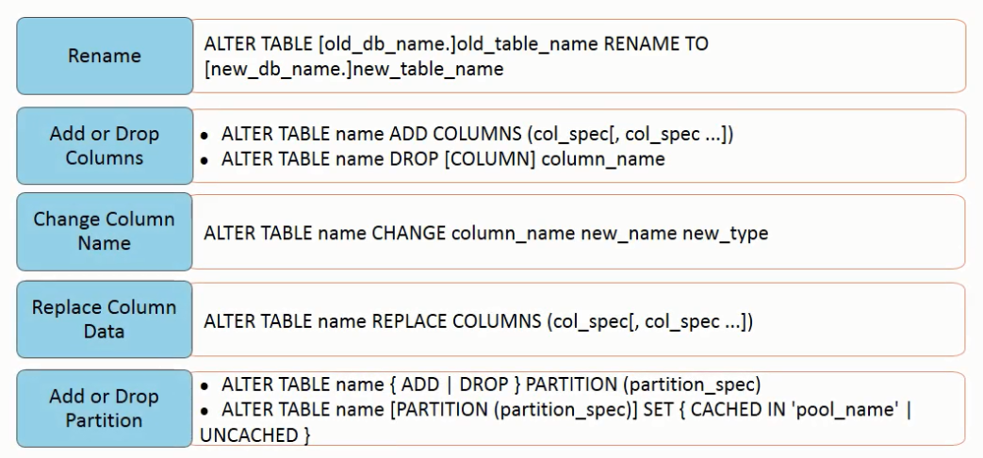

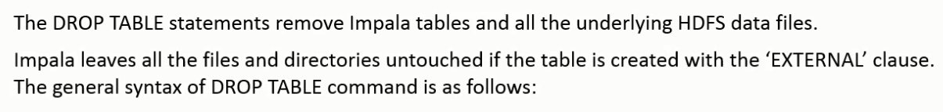





Describe



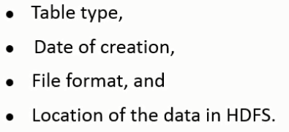

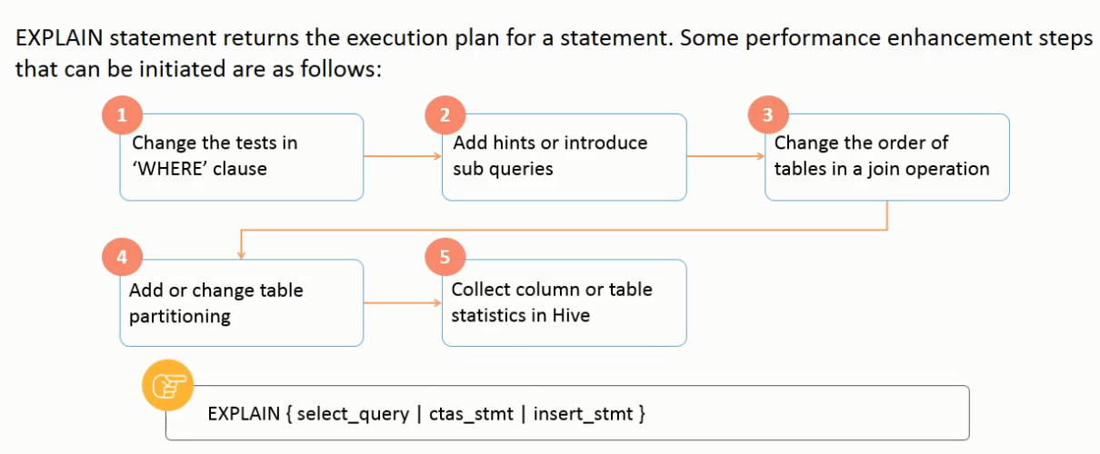

Show table

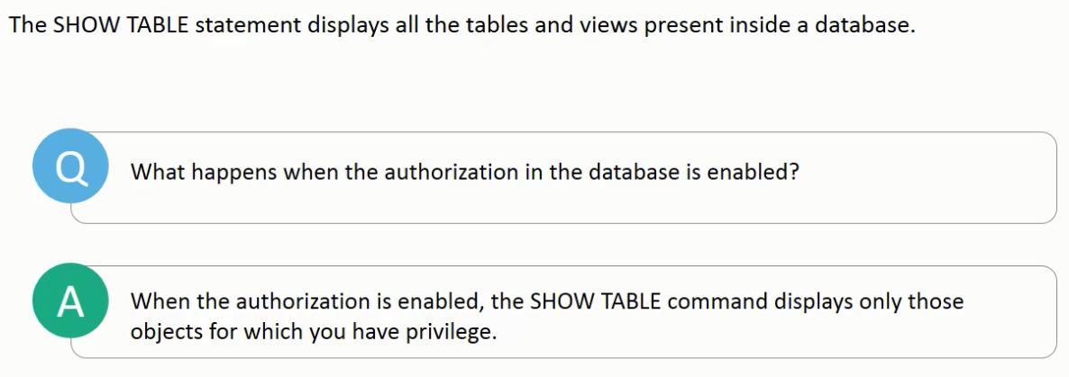

Insert

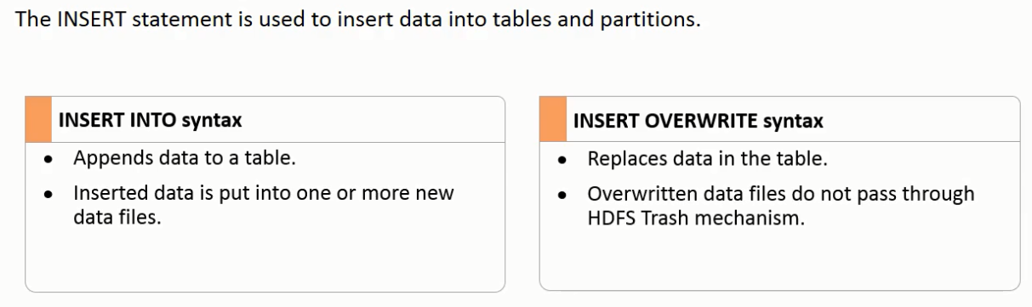

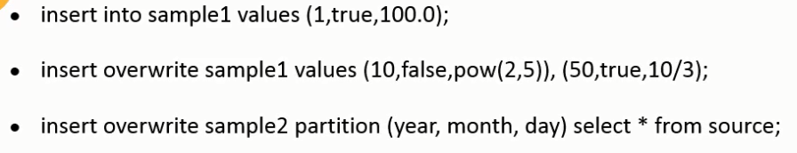

Select

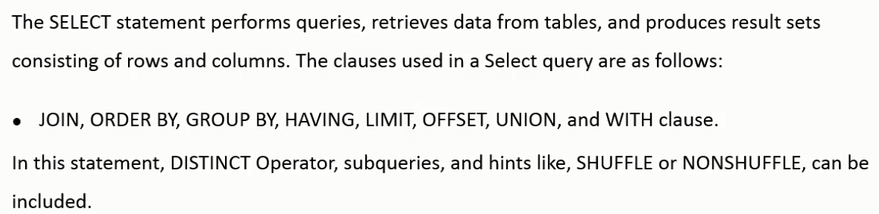

Built in Functions

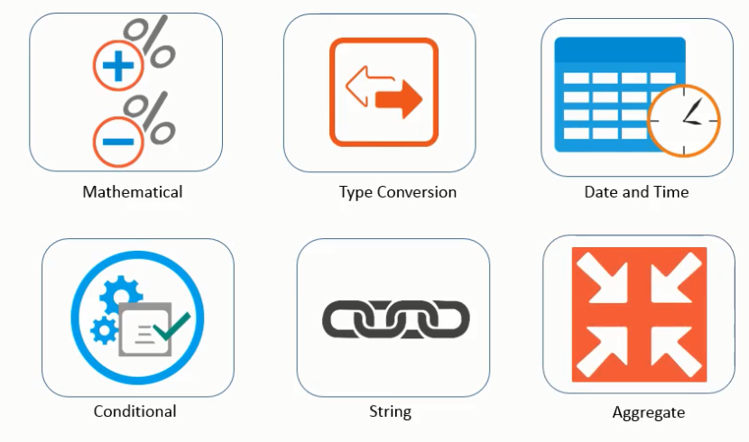

Create View

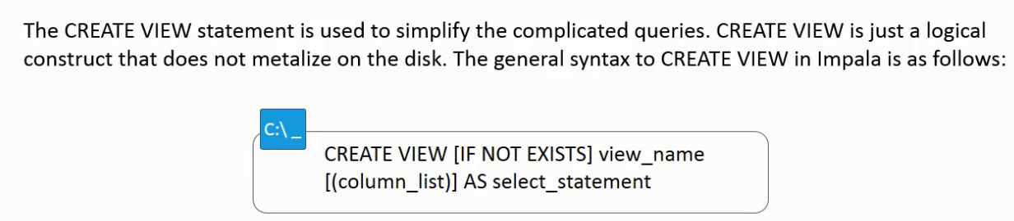

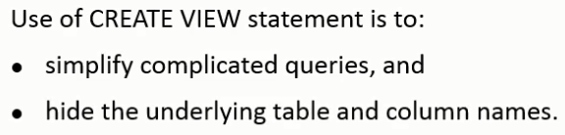

Difference between HQL and Imapala SQL

No MapReduce specified features in imapala such as ORDER BY, DISTRIBUTED BY, CLUSTER BY like Hive

Imapala has query hints that cannot be specified on Hive

Hive uses implicit casting unlike Imapala for string and numeric types but not amongst the numeric types. Imapala uses implicit casting from small int to big int but not vice versa.

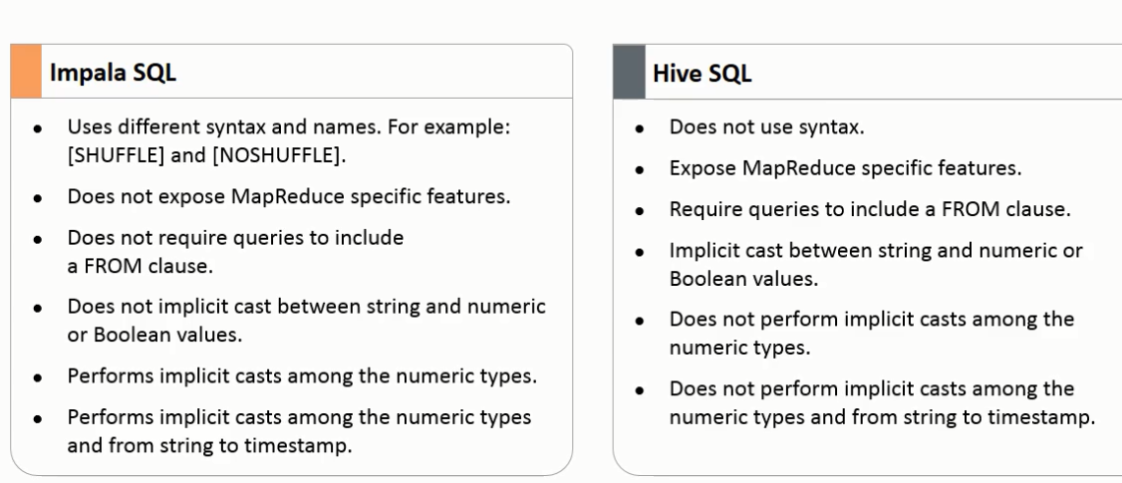

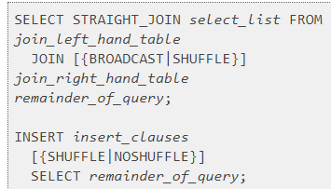

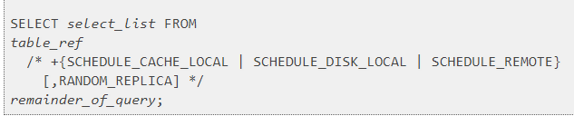

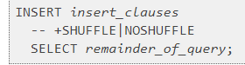

Explain

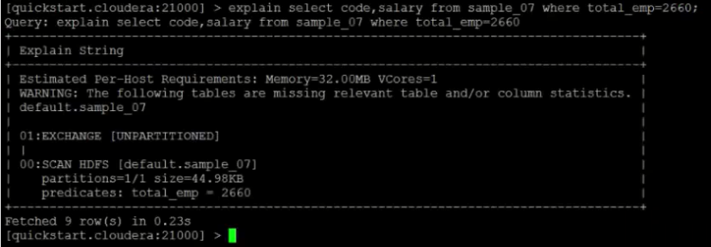

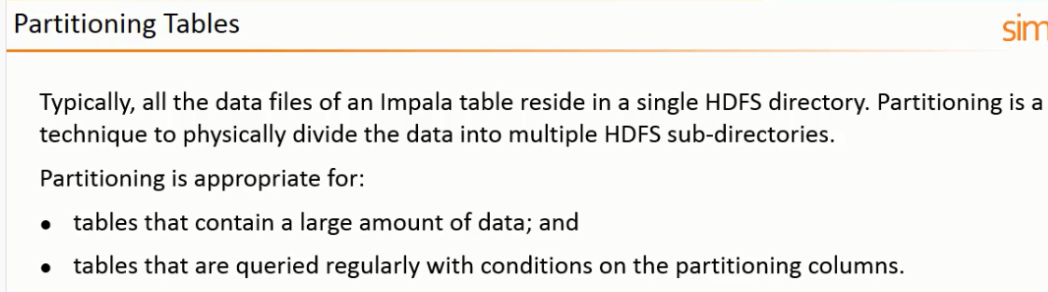

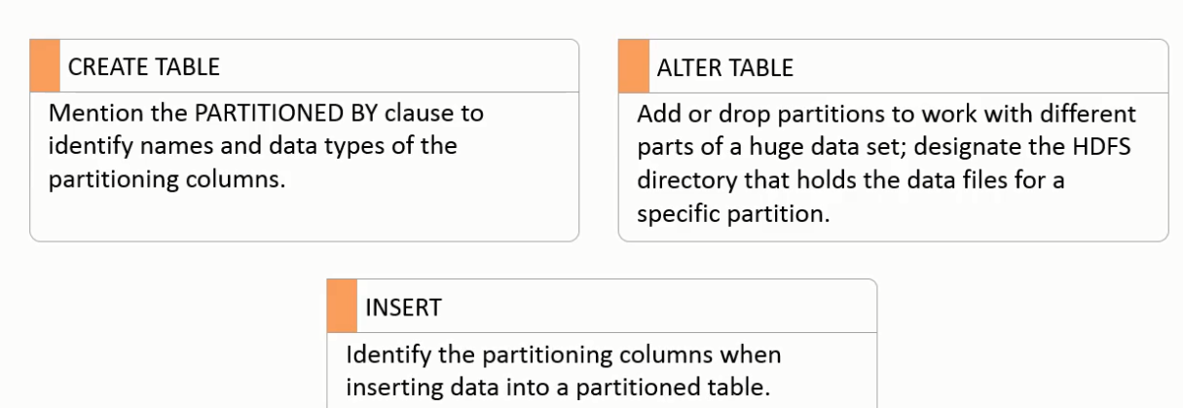

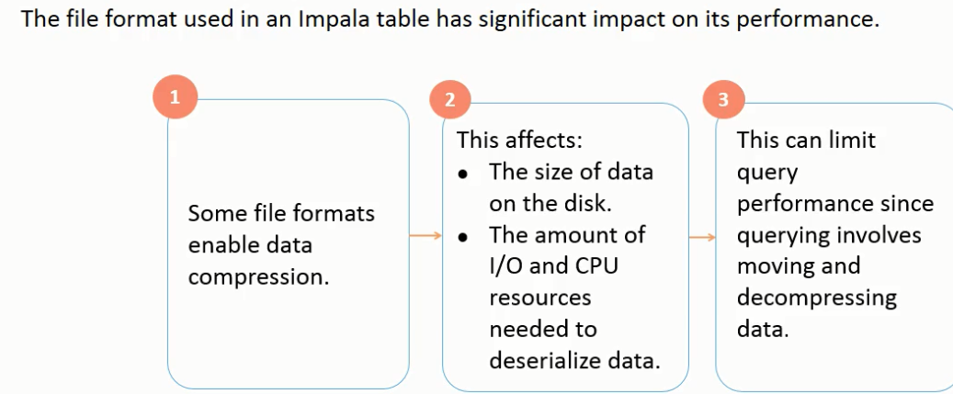

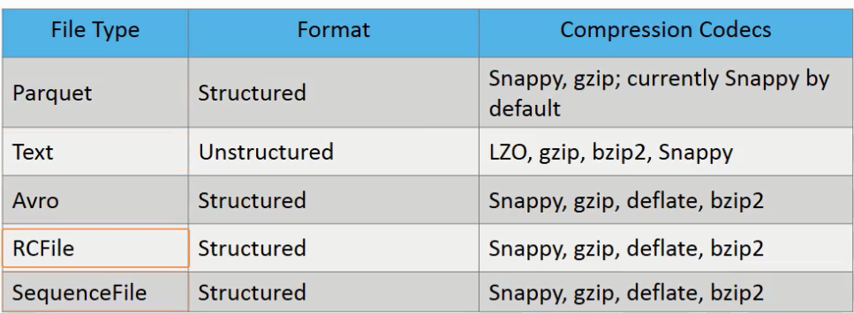

Imapala Architecture

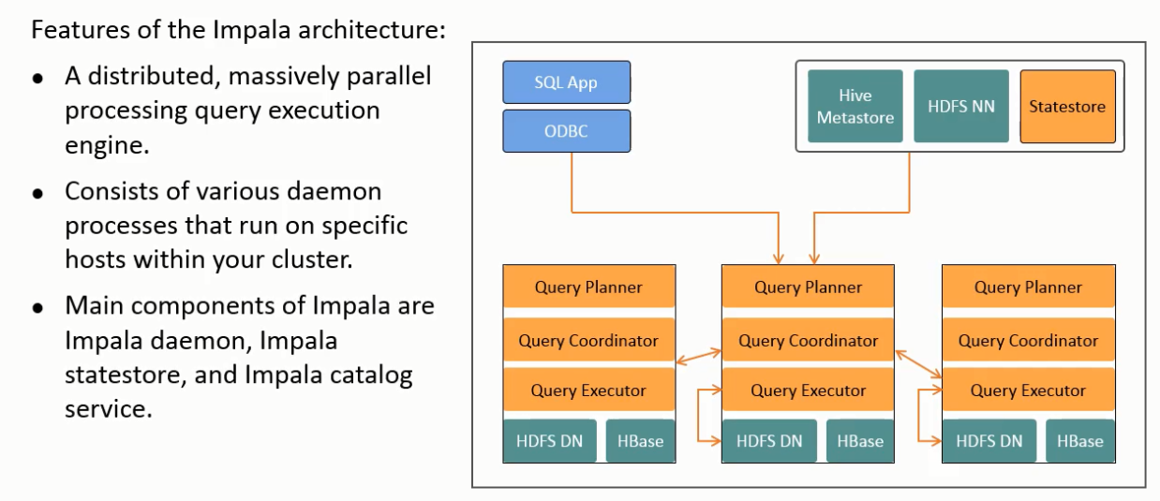

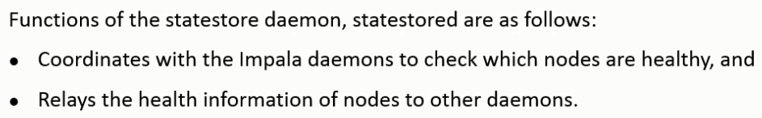

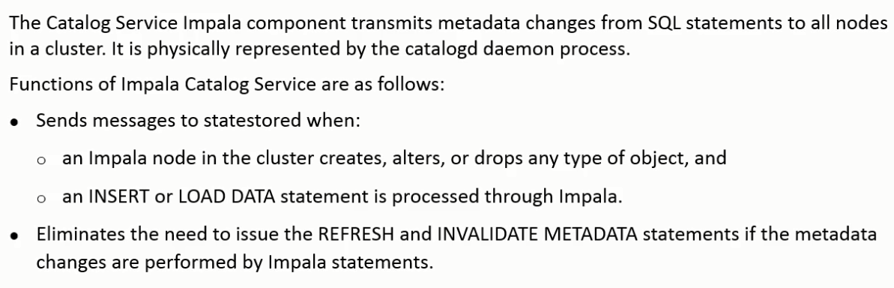

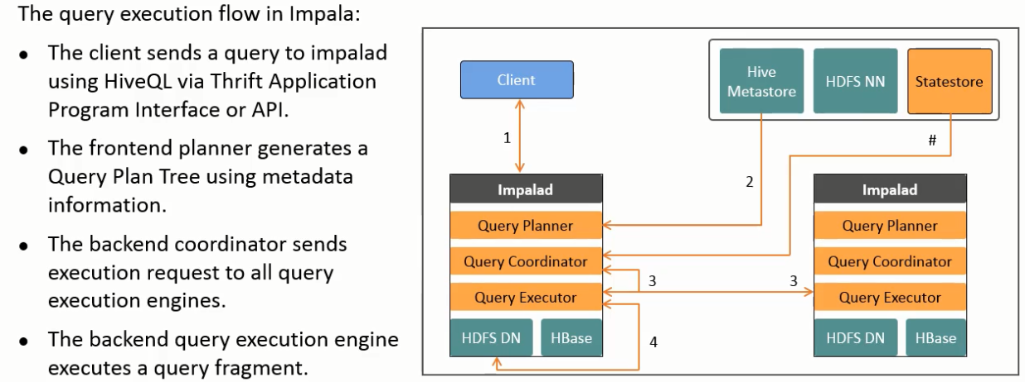

UDF and UDAF

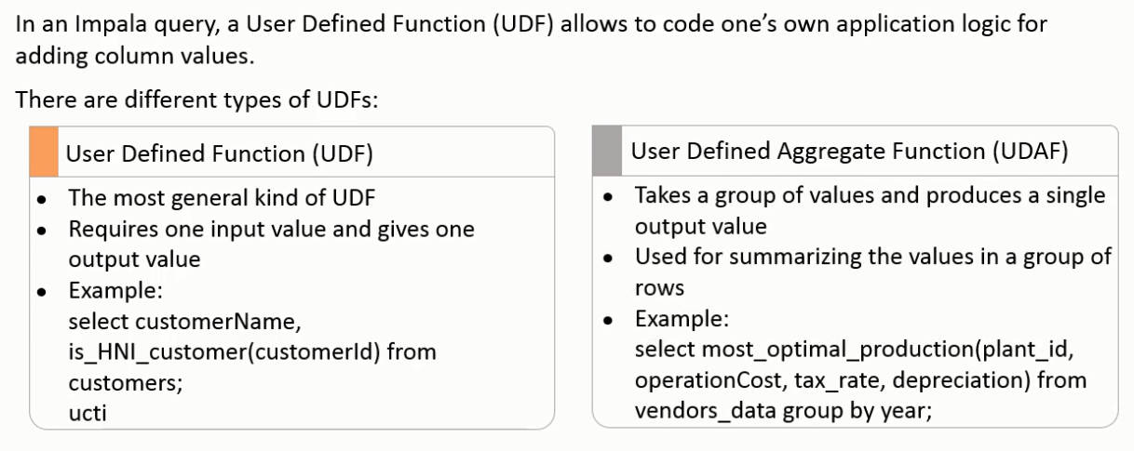

Running UDF written for Hive in Impala- only C++ UDF’s run fast. If in Java the following conditions need to be met:

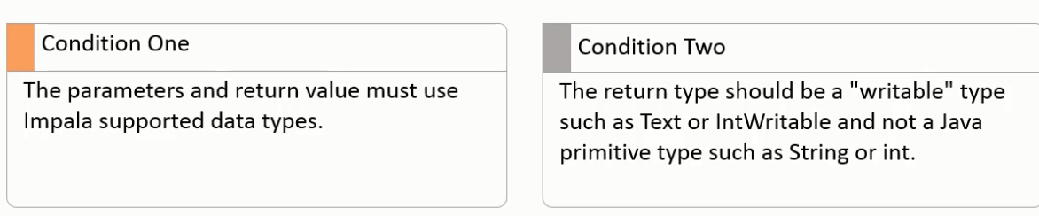

Improve Performance

